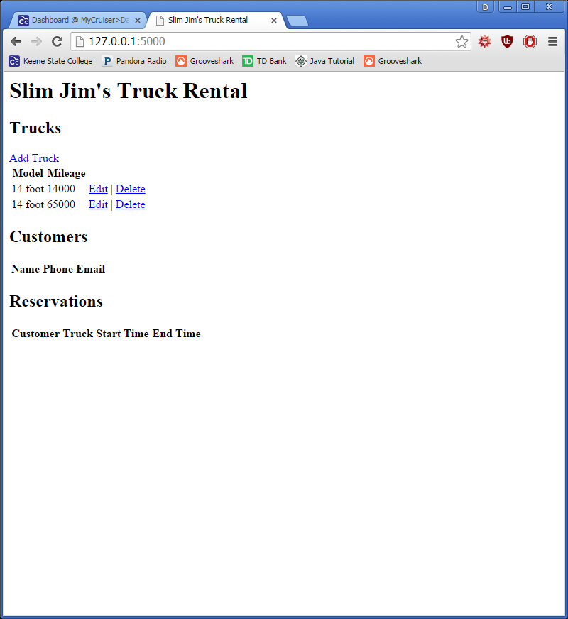
Our group has finished syncing all the files into one(syncEverything.php) and waiting for tanner and bryce to tell us what to do next.
We both completed our halves of redesigning the syncs so they may work in one file, making them easier to find.
They are now organized in one file in a forloop

